Trend Application Deployment using DevOps Tools

This project demonstrates the end-to-end deployment of a React application using modern DevOps tools including Terraform, Docker, Jenkins, Kubernetes (EKS), and monitoring with Prometheus and Grafana.

## Project Overview

This project automates the deployment of a React application using a CI/CD pipeline.

The workflow includes:

- Infrastructure provisioning using Terraform
- Containerization using Docker
- CI/CD pipeline using Jenkins
- Image storage in DockerHub
- Application deployment on AWS EKS
- Monitoring using Prometheus and Grafana

The application is deployed on Kubernetes and exposed using an AWS LoadBalancer.

Tools used :

Docker

Terraform

Jenkins

Kubernetes

Amazon EKS

Prometheus

Grafana

## Infrastructure Provisioning

Infrastructure is created using Terraform.

Resources created:

- VPC
- Subnets
- EC2 instance for Jenkins
- IAM Roles

Terraform Commands:

terraform init
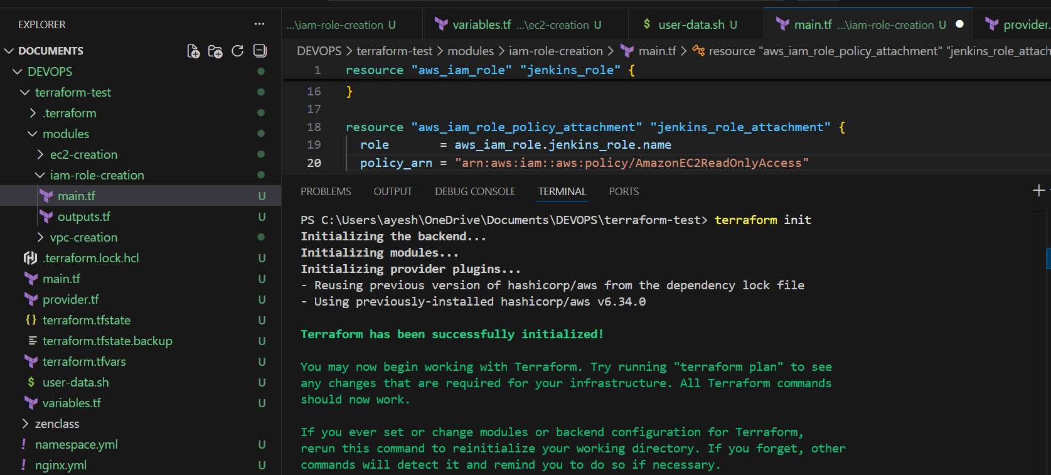

terraform plan
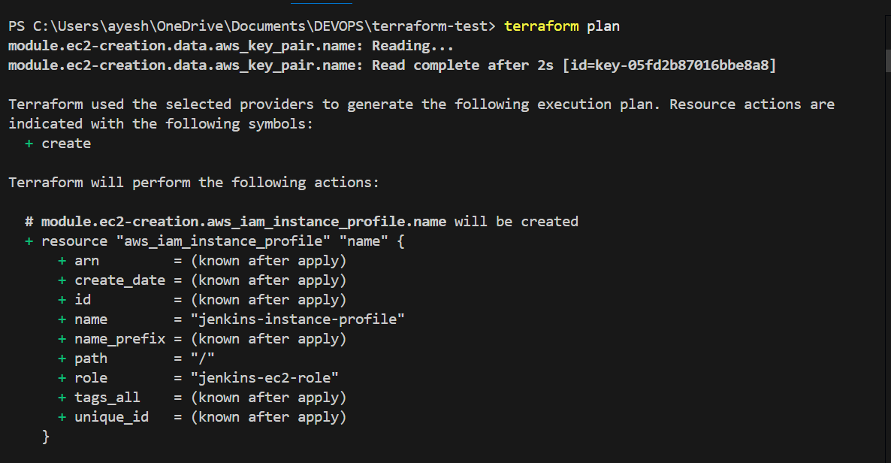
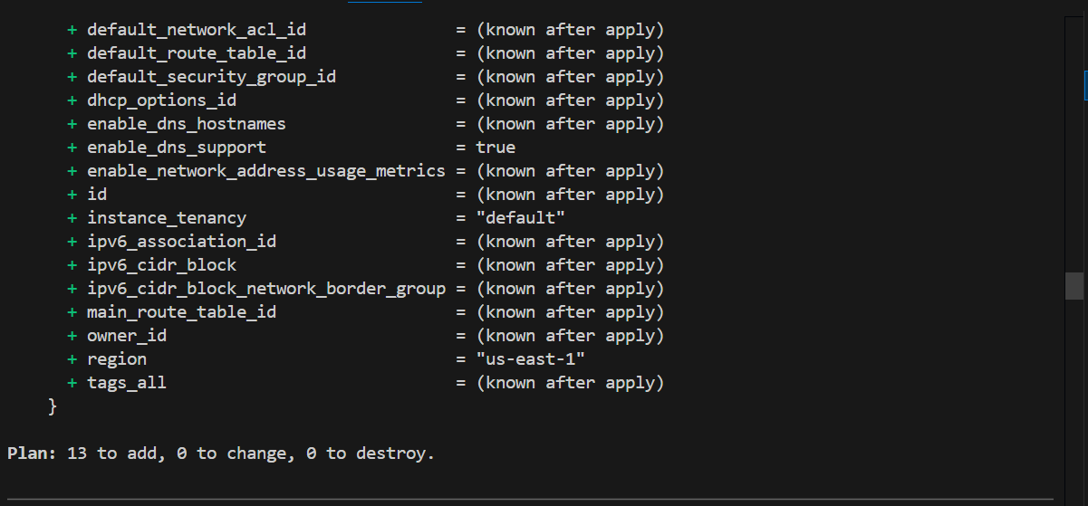

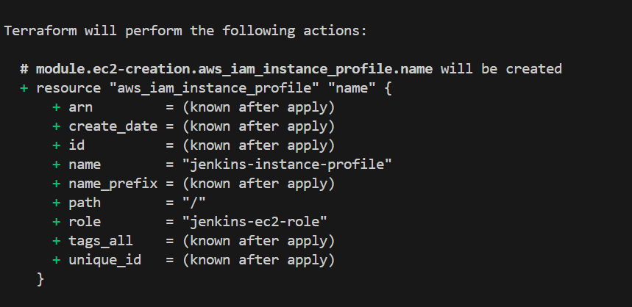
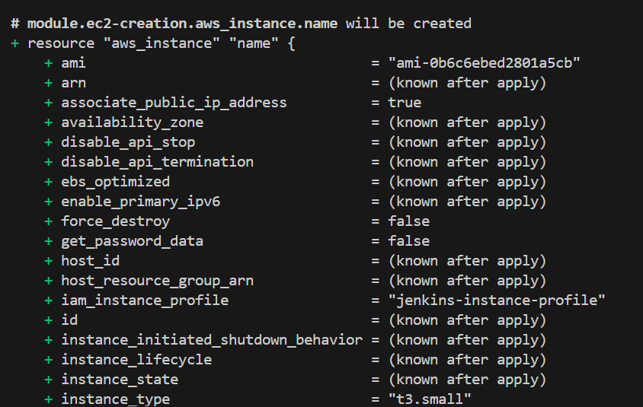

User data script to install jenkins, docker, kubectl , aws cli
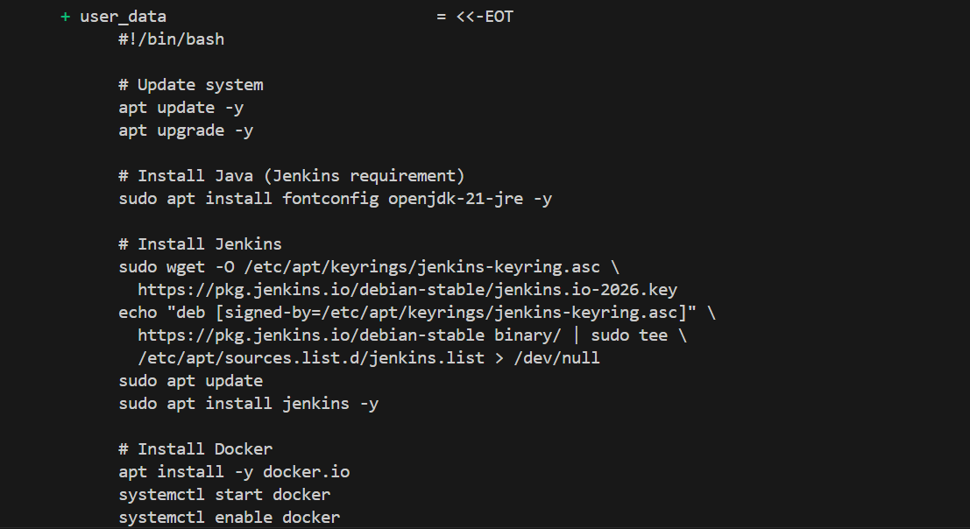

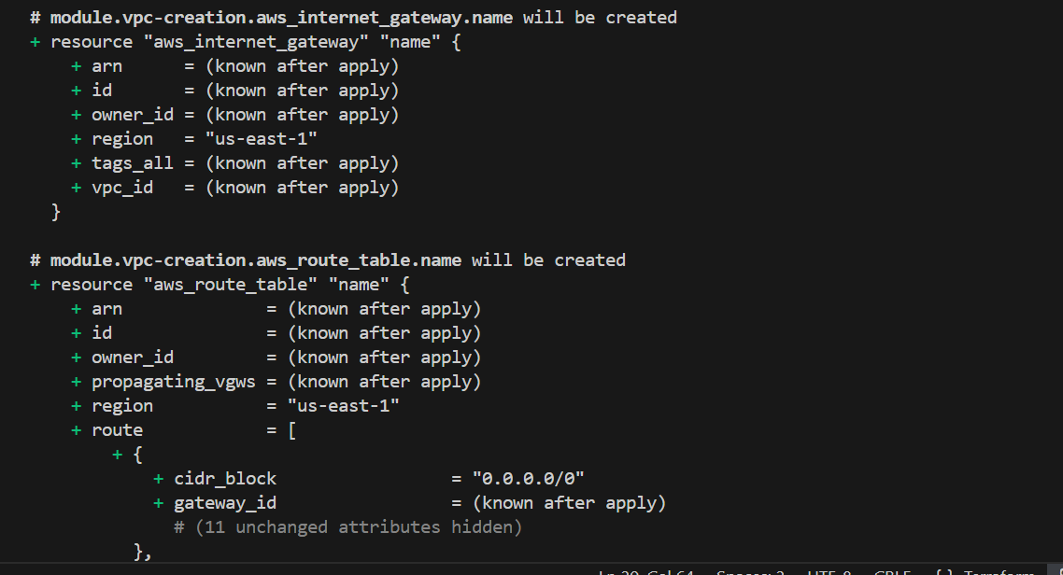

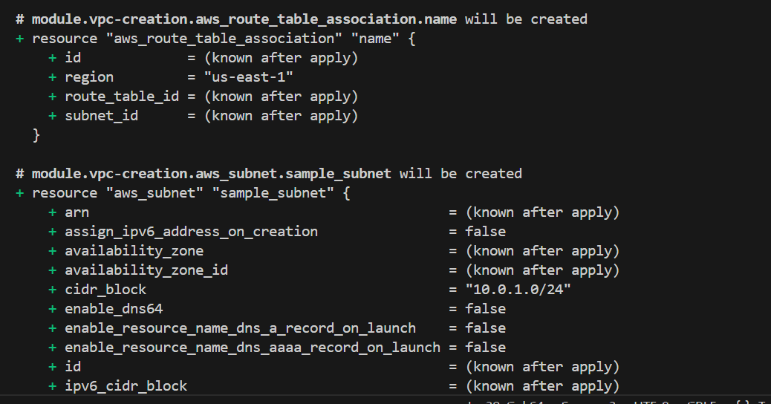

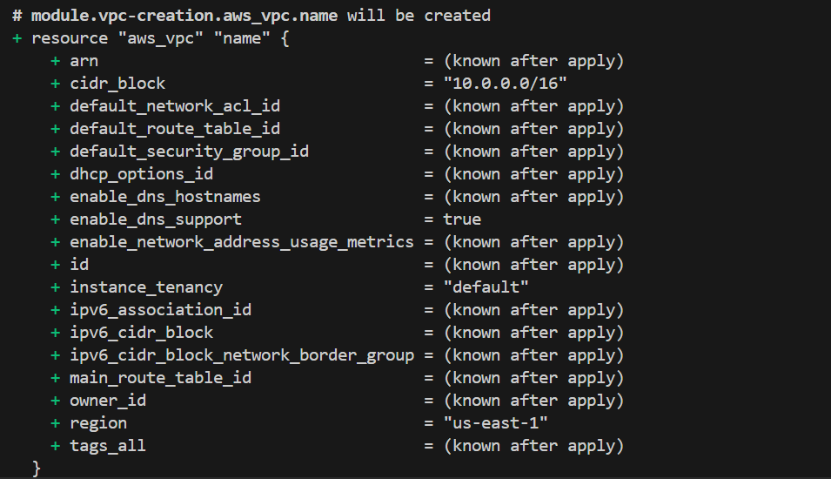

terraform apply

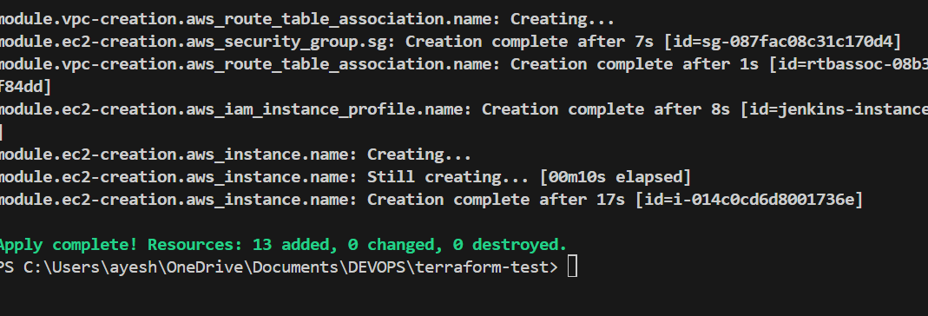

## Jenkins Pipeline
Jenkins installed through user data script.
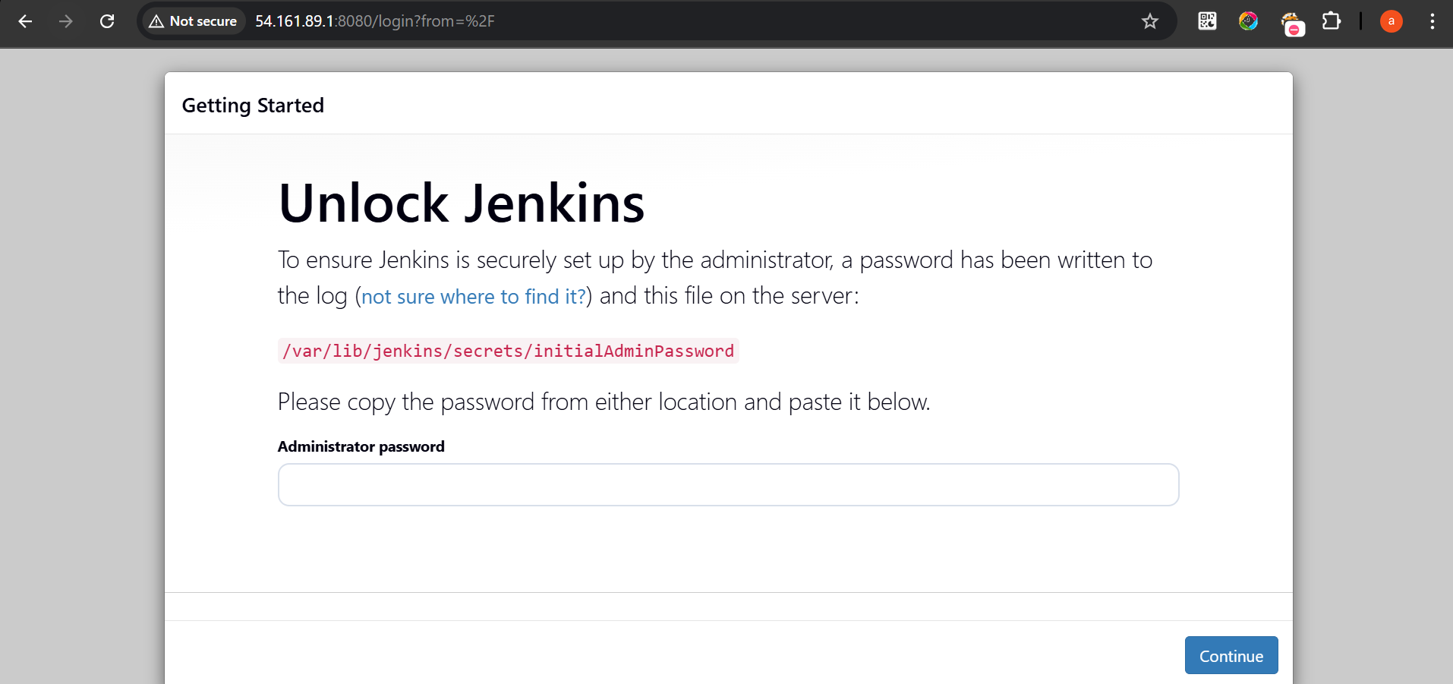

Jenkins is used to automate:
Web hook setup
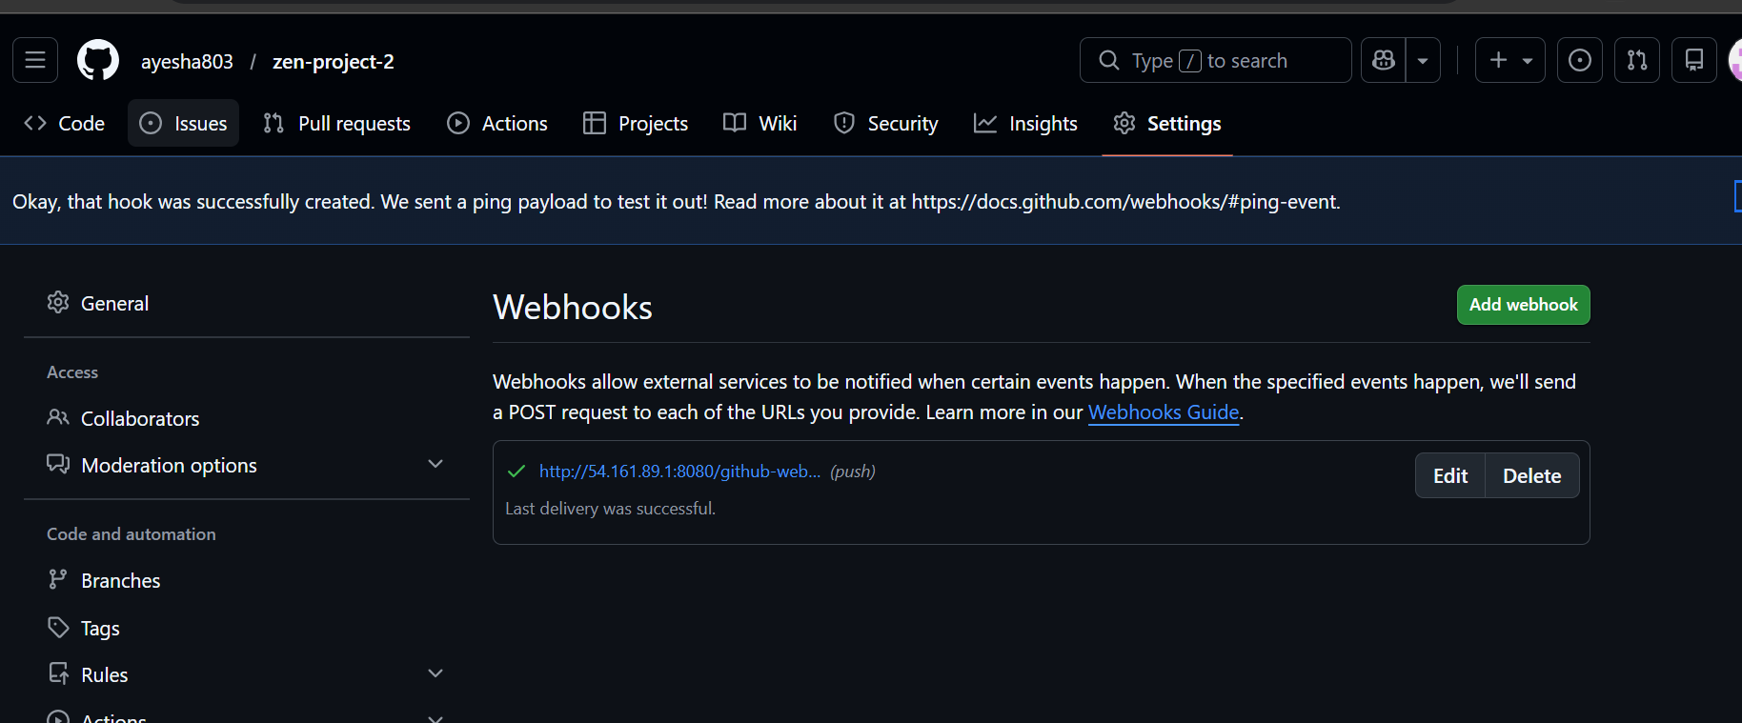

Created a pipeline
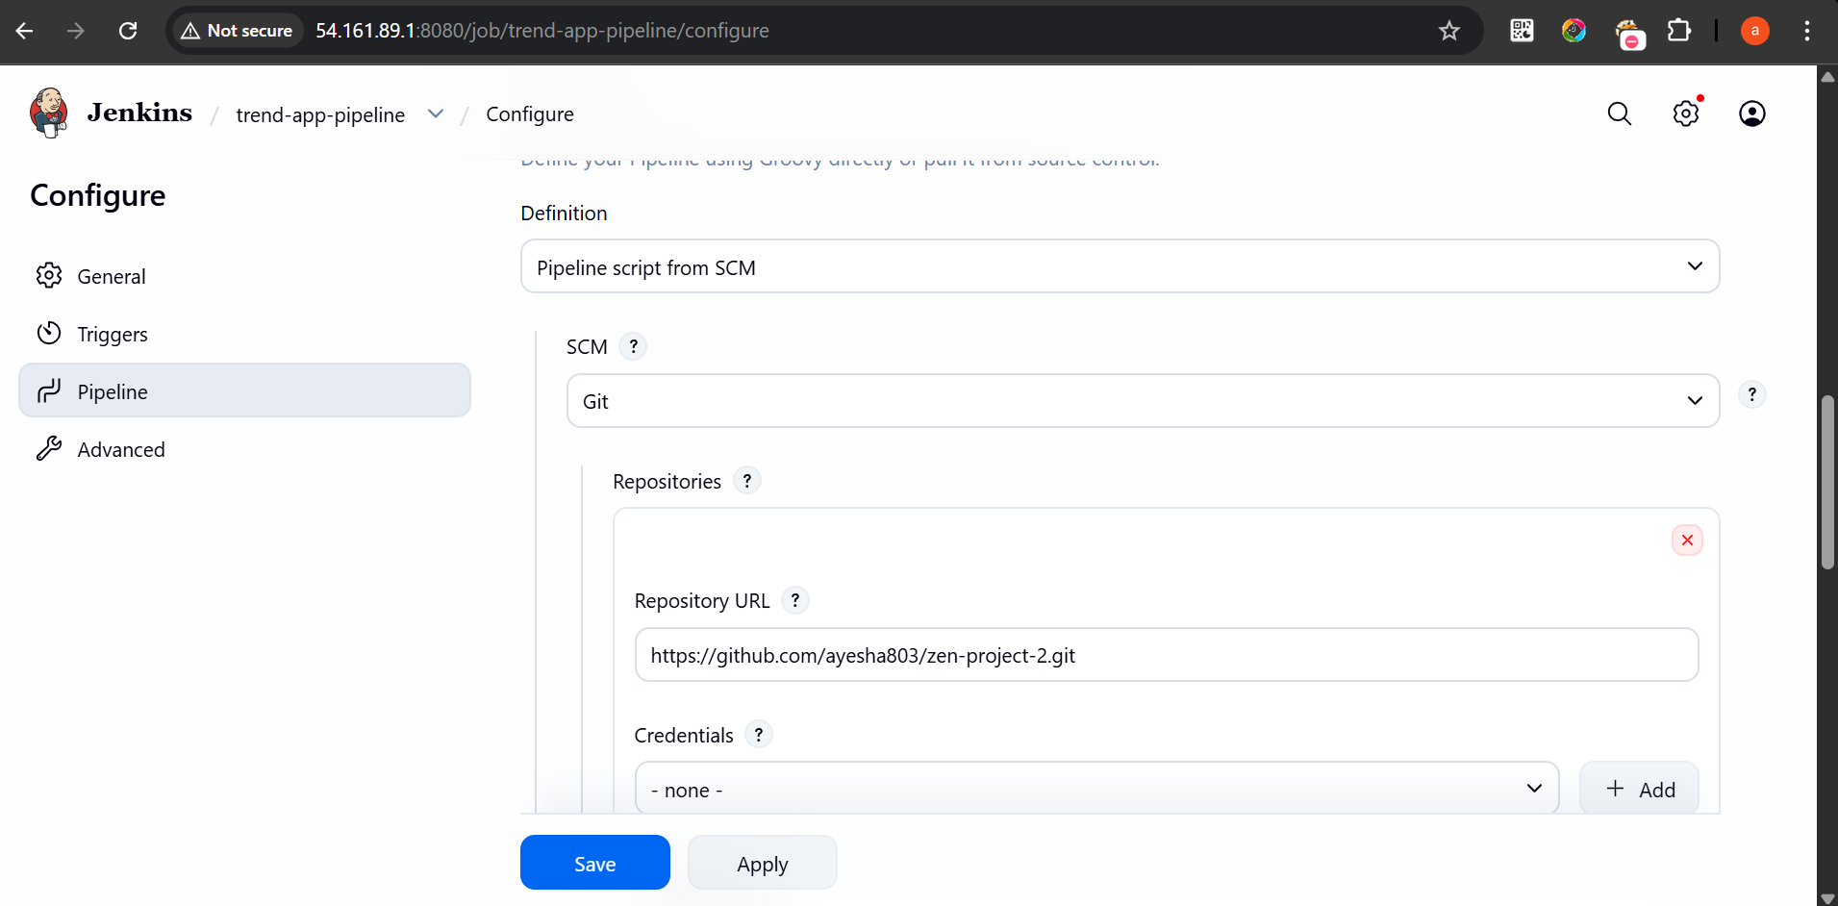

Created docker hub creds in jenkins ui
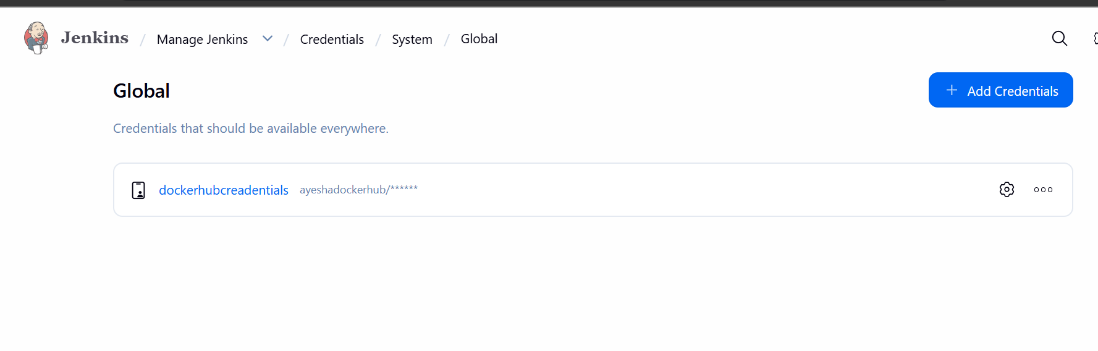

1. Pull code from GitHub
2. Build Docker image
3. Push image to DockerHub
4. Deploy application to Kubernetes

Pipeline stages:

Docker Build

Docker Login

Docker Push

## Kubernetes Deployment
Created EKS cluster
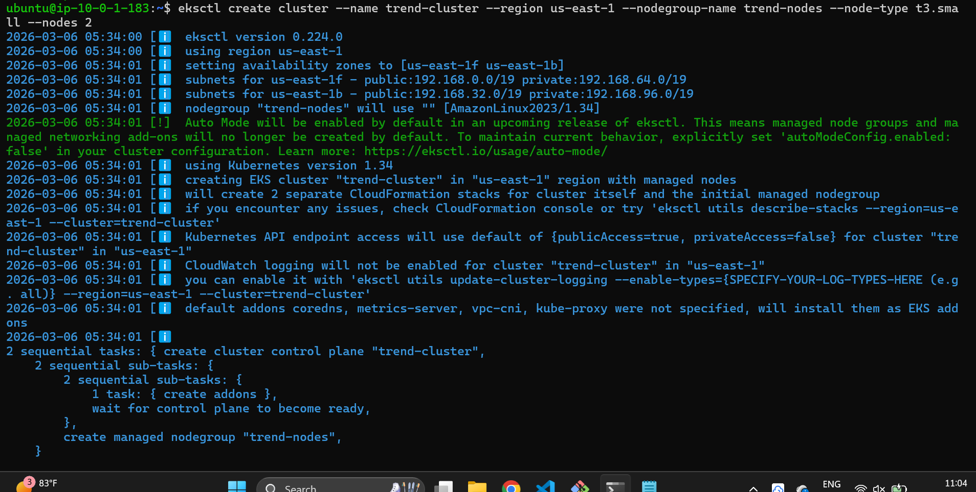

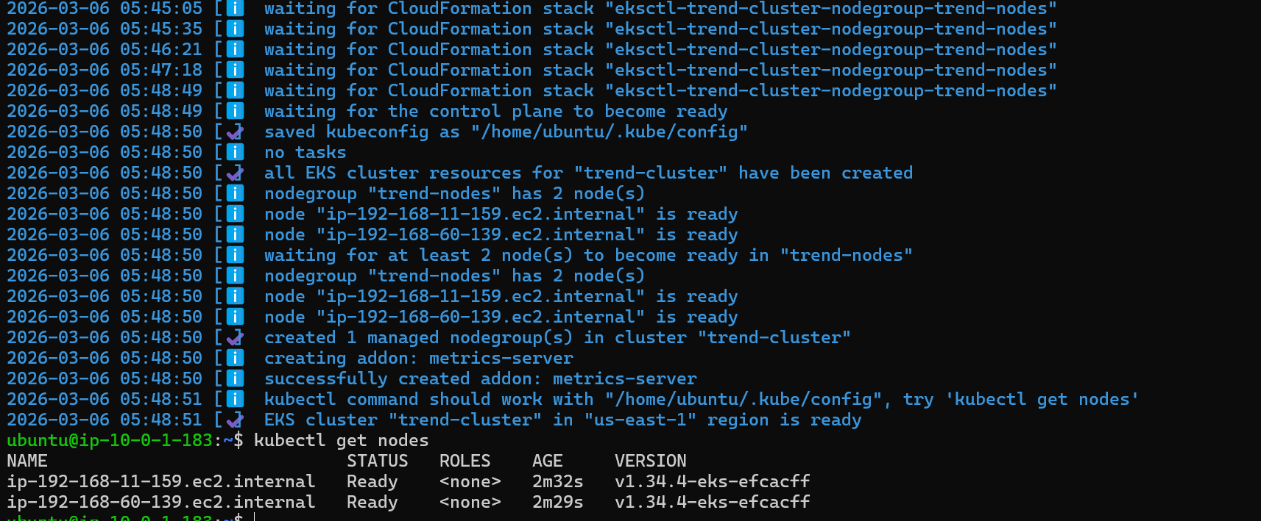

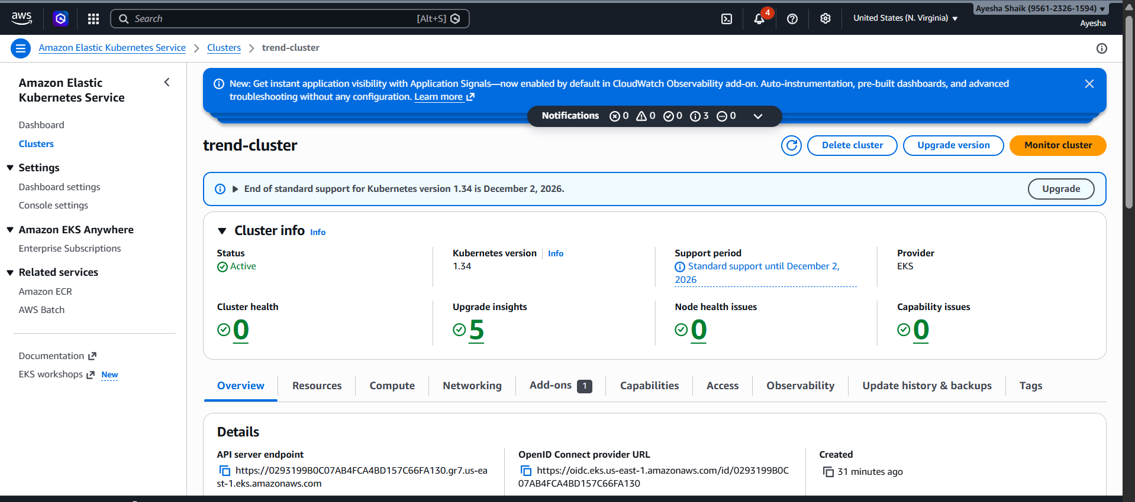

Application is deployed to AWS EKS using Kubernetes manifests.

Deployment file creates the application pods.

Service file exposes the application using AWS LoadBalancer.

kubectl apply -f deployment.yml
kubectl apply -f service.yml

Application deployed through jenkins pipeline

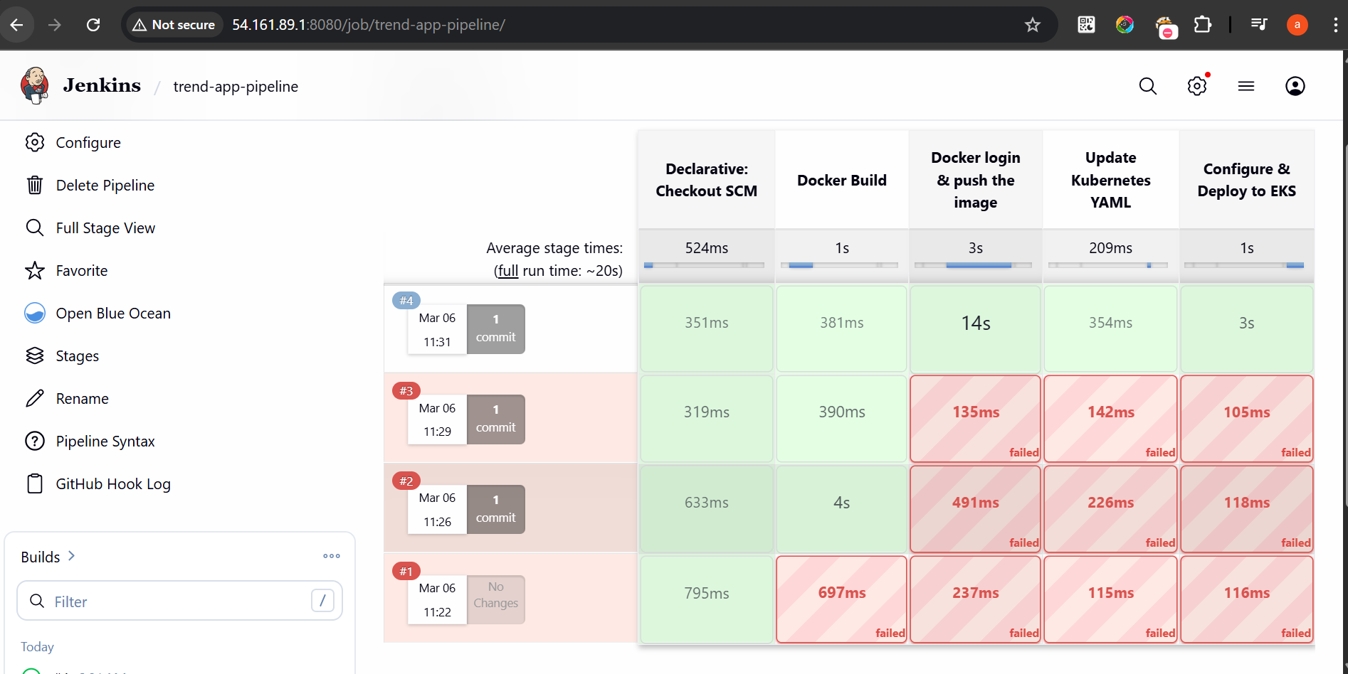

pipeline{
agent any
environment{
IMAGE_NAME = 'ayeshadockerhub/trend-app'
IMAGE_TAG = "${BUILD_NUMBER}"
CLUSTER_NAME = 'trend-eks-cluster'
AWS_REGION = 'us-east-1'
}
stages{
stage('Docker Build'){
steps{
sh "docker build -t $IMAGE_NAME:$IMAGE_TAG ."
}
}

stage ('Docker login & push the image'){
steps{
withCredentials([usernamePassword(credentialsId: 'dockerhubcreadentials', passwordVariable: 'DOCKER_PASSWORD', usernameVariable: 'DOCKER_USERNAME')]) {
sh '''echo $DOCKER_PASSWORD | docker login -u $DOCKER_USERNAME --password-stdin
'''
sh "docker push $IMAGE_NAME:$IMAGE_TAG"

}
}
}

stage('Update Kubernetes YAML'){
steps{
sh '''
sed -i "s|image: ayeshadockerhub/trend-app:.*|image: $IMAGE_NAME:$IMAGE_TAG|" trend-app.yml
'''
}
}

stage('Configure & Deploy to EKS'){
steps{
sh '''
aws eks update-kubeconfig --region us-east-1 --name trend-cluster

kubectl apply -f trend-app.yml
kubectl apply -f trend-service.yml
'''
}
}
}
}

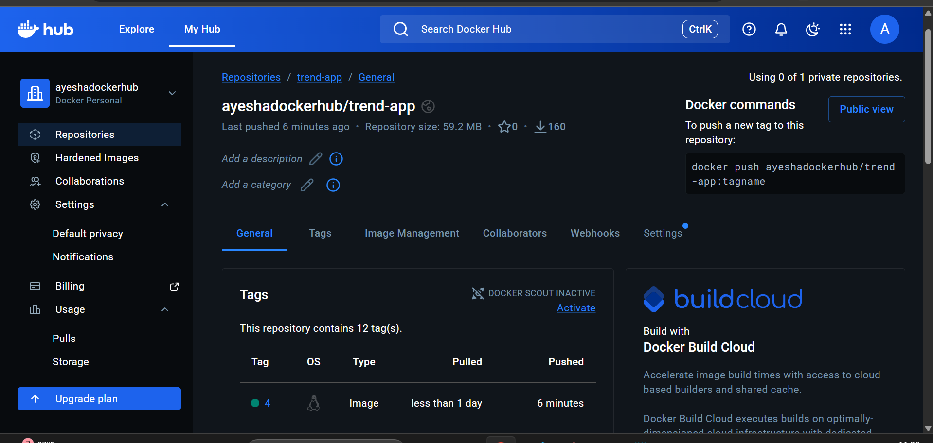

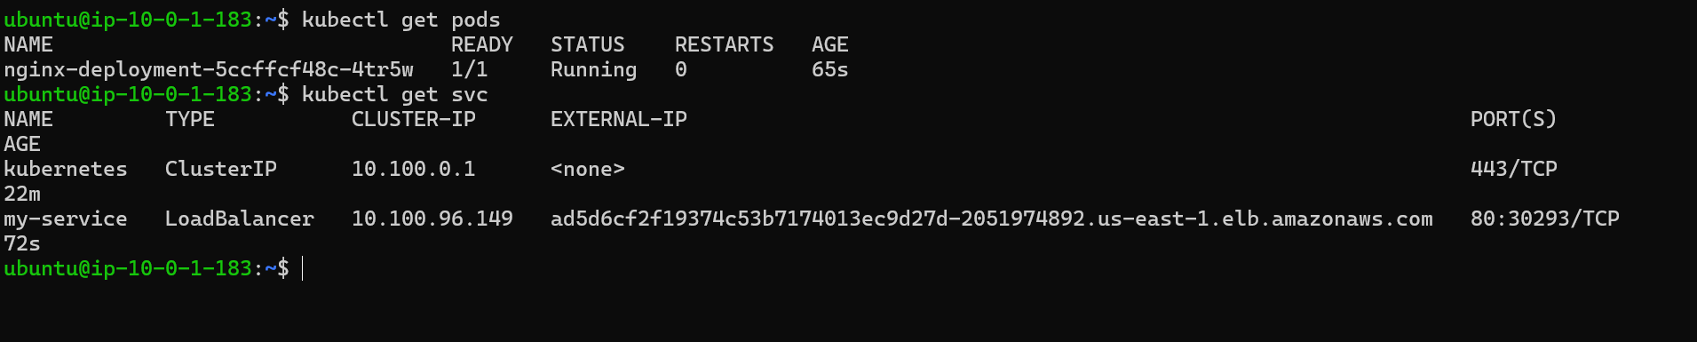

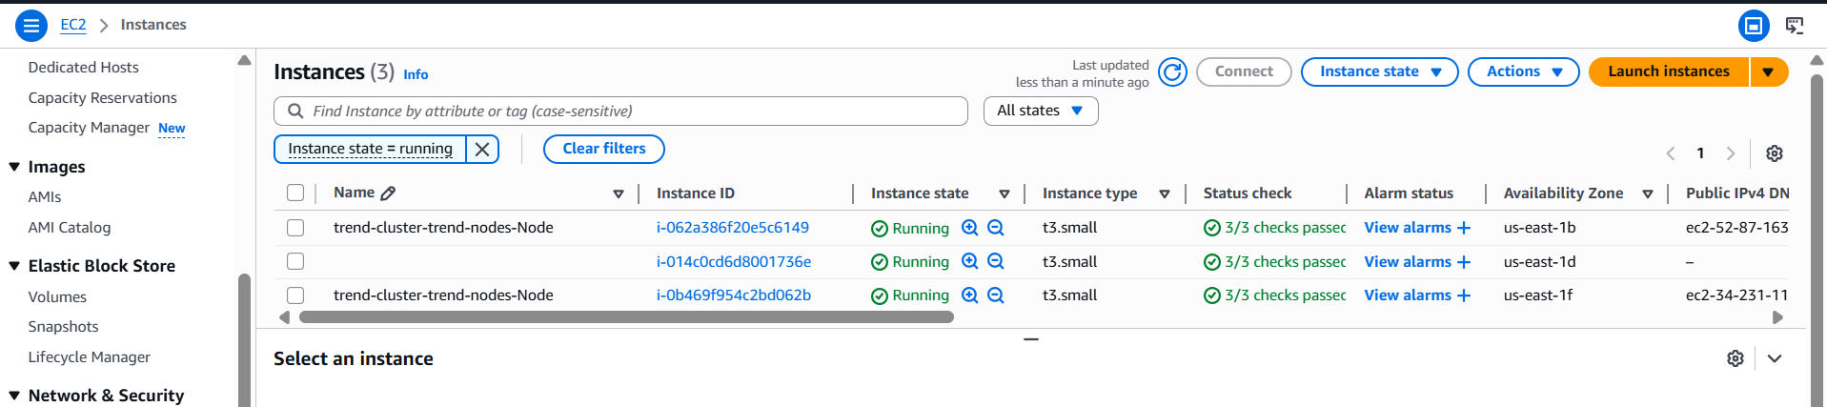

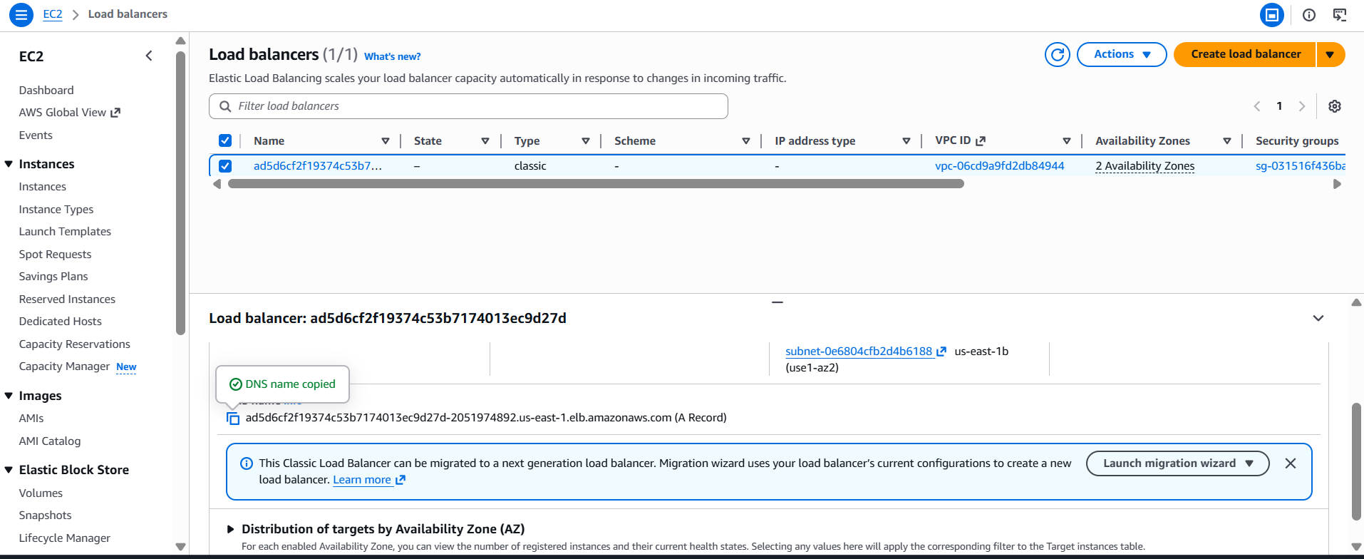

## Monitoring

Monitoring is implemented using Prometheus and Grafana inside the EKS cluster.
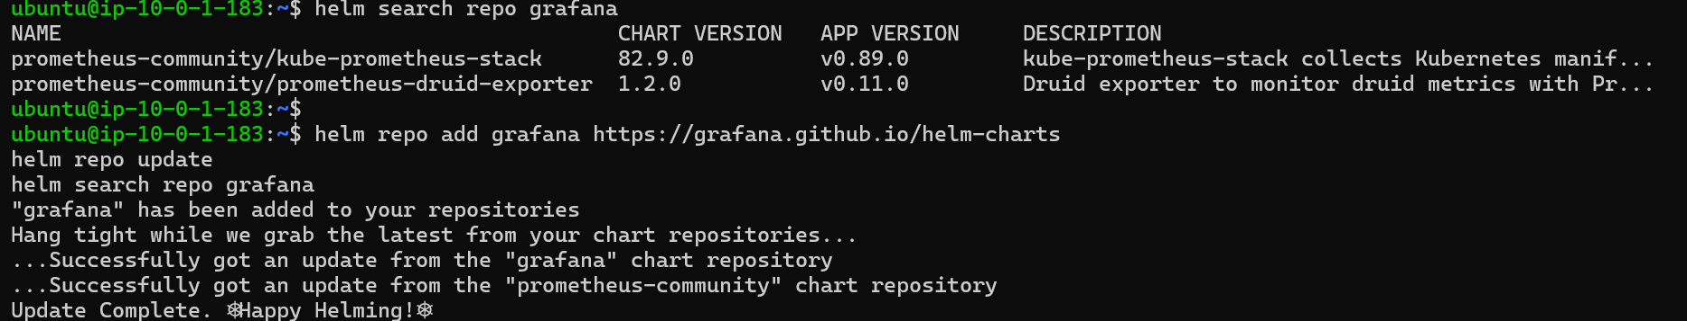
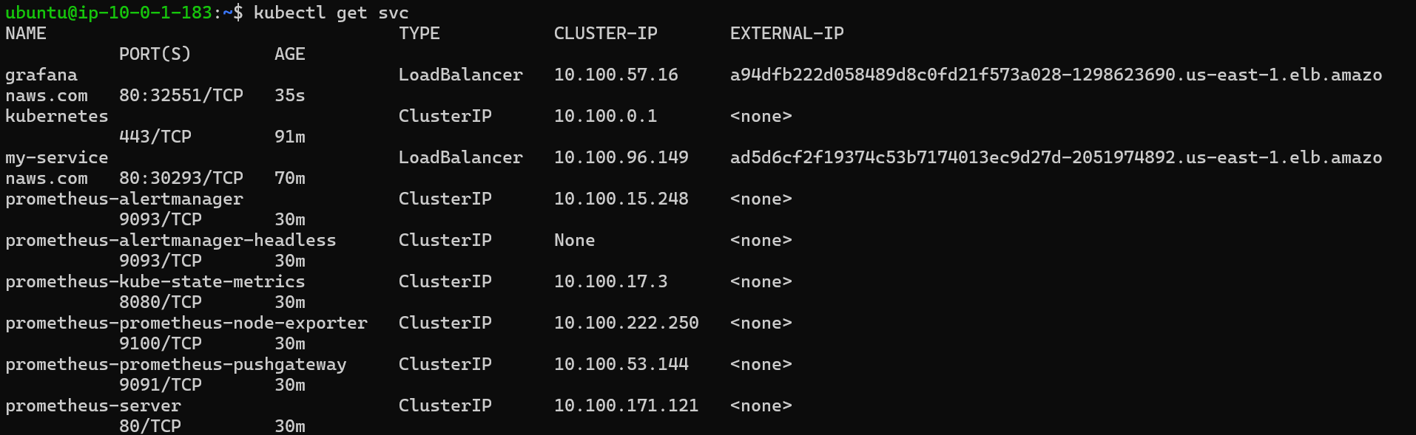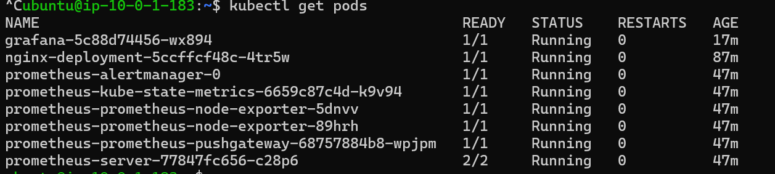

Prometheus collects metrics from:

- Kubernetes nodes
- Pods
- Containers

Grafana visualizes the metrics through dashboards.
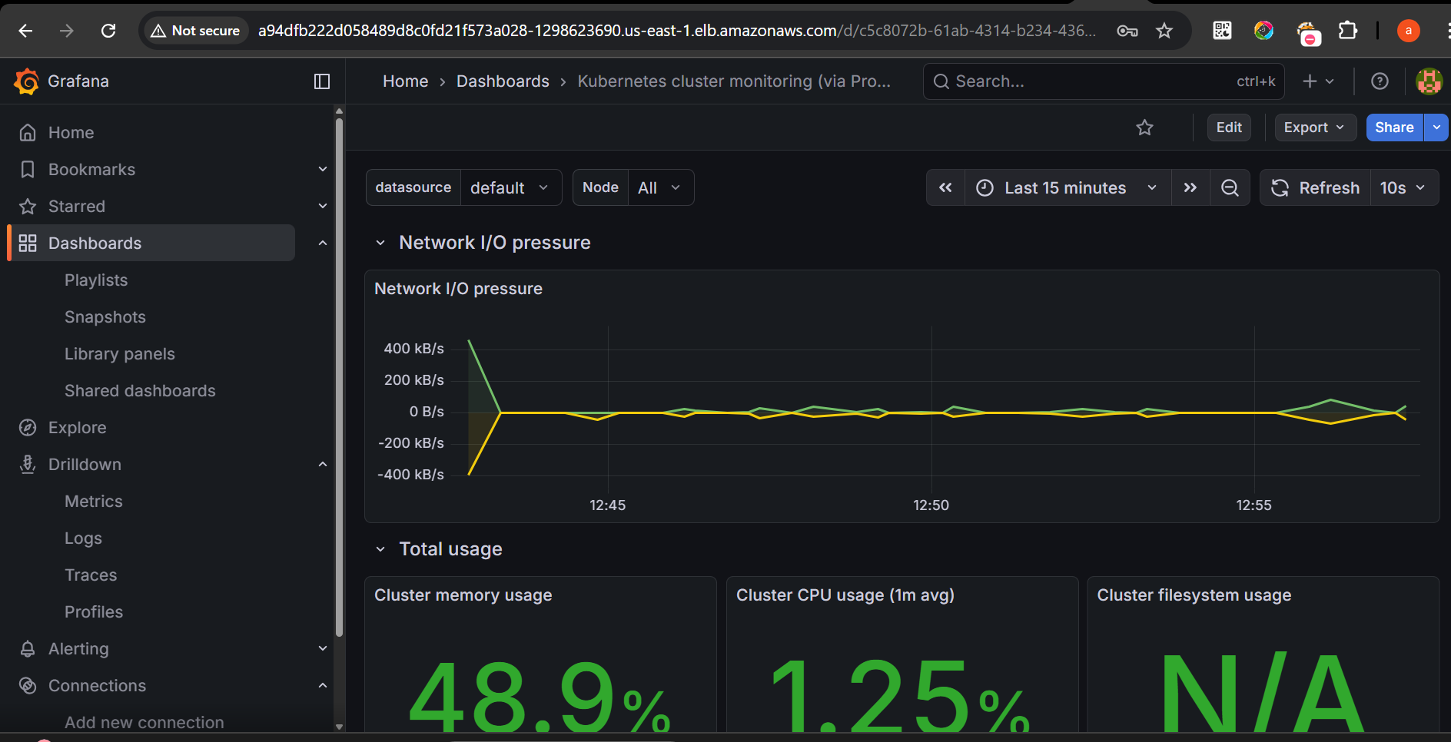

## Application Access

The application is exposed using an AWS LoadBalancer.



Example:
http://ad5d6cf2f19374c53b7174013ec9d27d-2051974892.us-east-1.elb.amazonaws.com

LoadBalancer ARN: ad5d6cf2f19374c53b7174013ec9d27d-2051974892.us-east-1.elb.amazonaws.com

